SET 3: EMPLOYEE PERFORMANCE EVALUATION
Dataset: Employee Performance
Department | AIDS
Course Code / Course Name | DSA0601 / Data Handling and Visualization
Experiment | Data Visualization using R
Name | B. Pallavi
Register Number | 192424243
Date | 29 September 2026
Day | Tuesday

Dataset: Employee Performance
Monthly Sales Data
Month | Sales ($)
January | 15000
February | 18000
March | 22000
April | 20000
May | 23000

Employee Data
Employee ID | Department | Years of Service | Performance Score
1 | Sales | 5 | 85
2 | HR | 3 | 92
3 | Marketing | 7 | 78
4 | Sales | 4 | 90
5 | HR | 2 | 76

PROGRAM 1: Line Chart of Monthly Sales
Create a line chart to visualize the monthly sales trend. Label the axes and title the chart appropriately.
# Dataset
month <- c("January", "February", "March", "April", "May")
sales <- c(15000, 18000, 22000, 20000, 23000)

# Line Chart
plot(sales,
type = "o",
xaxt = "n",
xlab = "Month",
ylab = "Sales ($)",
main = "Monthly Sales Performance",
col = "blue")
axis(1, at = 1:5, labels = month)

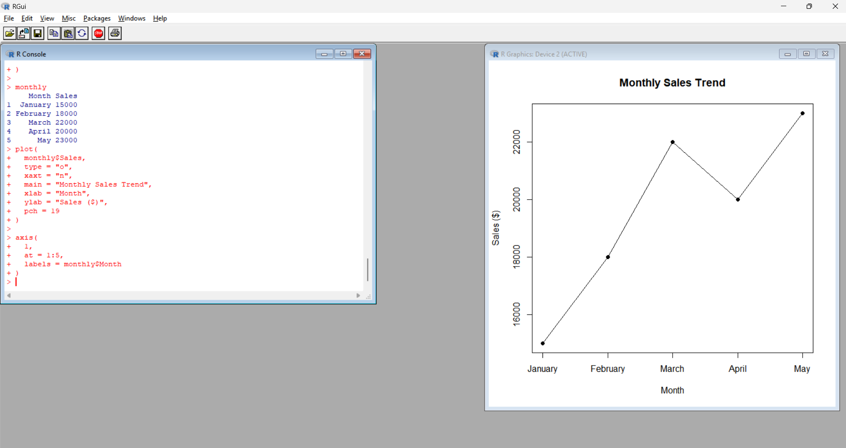

Output 1: Line chart
Observation:
Sales increase from January to March, decrease slightly in April, and reach the highest value in May.
PROGRAM 2: Bar Chart of Employees by Department
Generate a bar chart to display the distribution of employees across different departments.
# Dataset
department <- c("Sales", "HR", "Marketing", "Sales", "HR")

# Calculate department frequency
department_count <- table(department)

# Bar Chart
barplot(department_count,
xlab = "Department",
ylab = "Number of Employees",
main = "Employees by Department",
col = "skyblue")
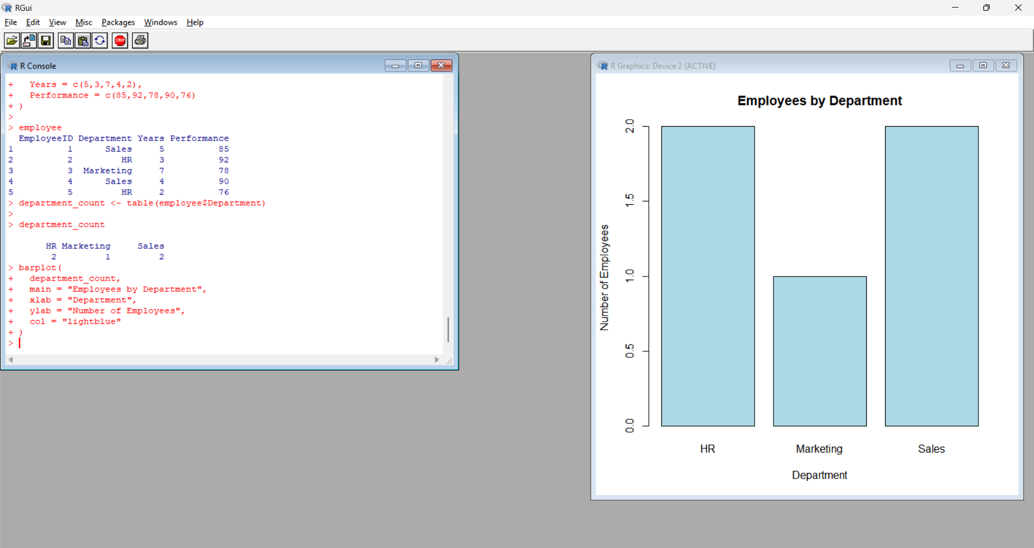
Output 2: Bar graph
Observation: The Sales and HR departments each have two employees, while the Marketing department has one employee.
PROGRAM 3: Scatter Plot of Years of Service vs Performance Score
Develop a scatter plot to explore the relationship between employee experience and performance score.
# Dataset
years <- c(5, 3, 7, 4, 2)
performance <- c(85, 92, 78, 90, 76)

# Scatter Plot
plot(years, performance,
main = "Years of Service vs Performance Score",
xlab = "Years of Service",
ylab = "Performance Score",
pch = 19,
col = "red")

# Trend line
abline(lm(performance ~ years),
col = "blue",
lwd = 2)
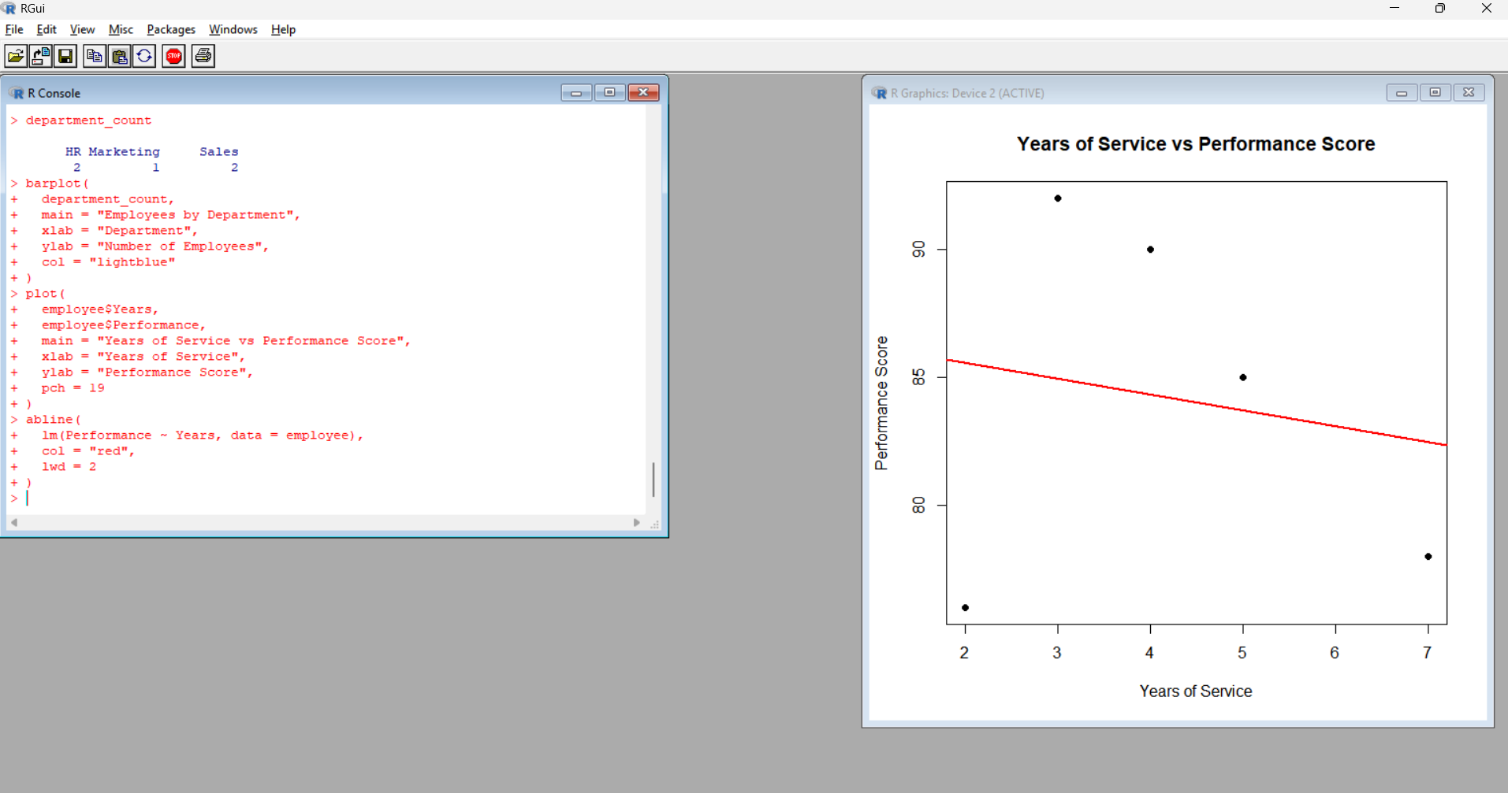
Output 3: Scatter plot
Note: The scatter plot shows the relationship between years of service and performance score. In this small dataset, employees with more years of service do not necessarily have higher performance scores.
PROGRAM 4: Interactive Employee Performance Dashboard
Build an interactive dashboard using Tableau to combine the monthly sales line chart and employee department bar chart.
Step 1: Create Excel File
Open Excel and enter the following data in Sheet 1:
Month | Sales
January | 15000
February | 18000
March | 22000
April | 20000
May | 23000
Rename Sheet 1 as:
Monthly Sales
Create Sheet 2:
Employee ID | Department | Years of Service | Performance Score
1 | Sales | 5 | 85
2 | HR | 3 | 92
3 | Marketing | 7 | 78
4 | Sales | 4 | 90
5 | HR | 2 | 76
Rename Sheet 2 as:
Employee Performance
Save the file as:
Employee_Performance.xlsx

Tableau Dashboard Procedure
Step 1: Open Tableau
Open Tableau Desktop.
Step 2: Connect Excel
- Click Microsoft Excel.
- Select Employee_Performance.xlsx.
- Click Open.
Step 3: Create Monthly Sales Line Chart
- Open Sheet 1.
- Drag Month → Columns.
- Drag Sales → Rows.
- Select Line from the Marks card.
- Rename the sheet:
Monthly Sales
Step 4: Create Department Bar Chart
- Click New Worksheet.
- Drag Department → Columns.
- Drag Employee ID → Rows.
- Select Bar from the Marks card.
- Rename the sheet:
Employees by Department
Step 5: Create Dashboard
- Click New Dashboard.
- Set the dashboard size if required.
- Drag Monthly Sales into the dashboard.
- Drag Employees by Department below or beside it.
- Add the title:
Employee Performance Evaluation Dashboard
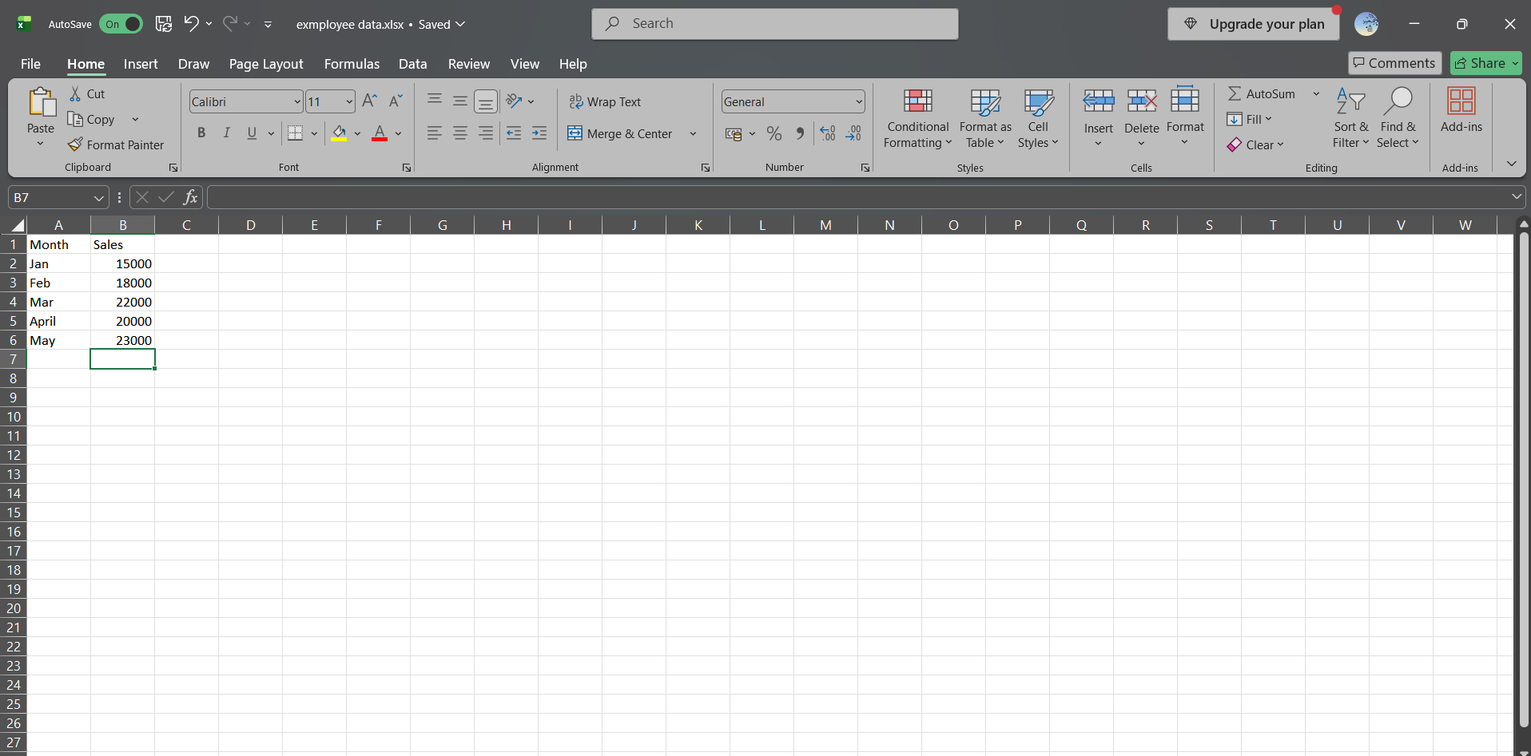
Output 4: dashboaard
RESULT: The employee performance data was successfully visualized using line, bar, and scatter charts in R. An interactive Tableau dashboard was also created by combining the monthly sales and employee department visualizations.

